Expedition Informative Document
2 days Tadoussac—Mer et monde écotours

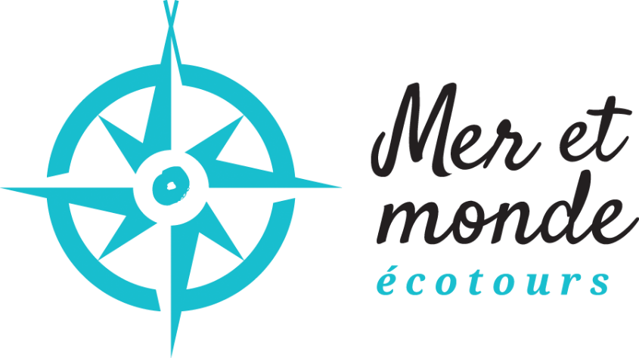

Update
December 06, 2023

Introduction

Hi, Kuei,
Thank you for your interest regarding our 2-day expedition, from Tadoussac to Mer et monde écotours. This product is made accessible to most people from 14 years old (refer to Kayak-camping teenager’s family), to discover our marine environment and in search of adventure and personal achievement. No need to be a seal to take part in this amazing odyssey.
Have you ever practised backcountry camping and sea kayaking? Then you are the perfect candidate! Do things differently, step out of your routine and get on board to experience our lifestyle while respecting the environment and contemplating wildlife. Memories guaranteed…
This informative document will provide you with all the information you need to get the most from our product and maximize your preparation. The information in this document may differ depending on the date of your departure. You’re always welcome to contact us if you have further questions. Please note that we will contact you one (1) month before your departure date.
We wish a pleasant reading and a wonderful experience!

From the activitie’s team,
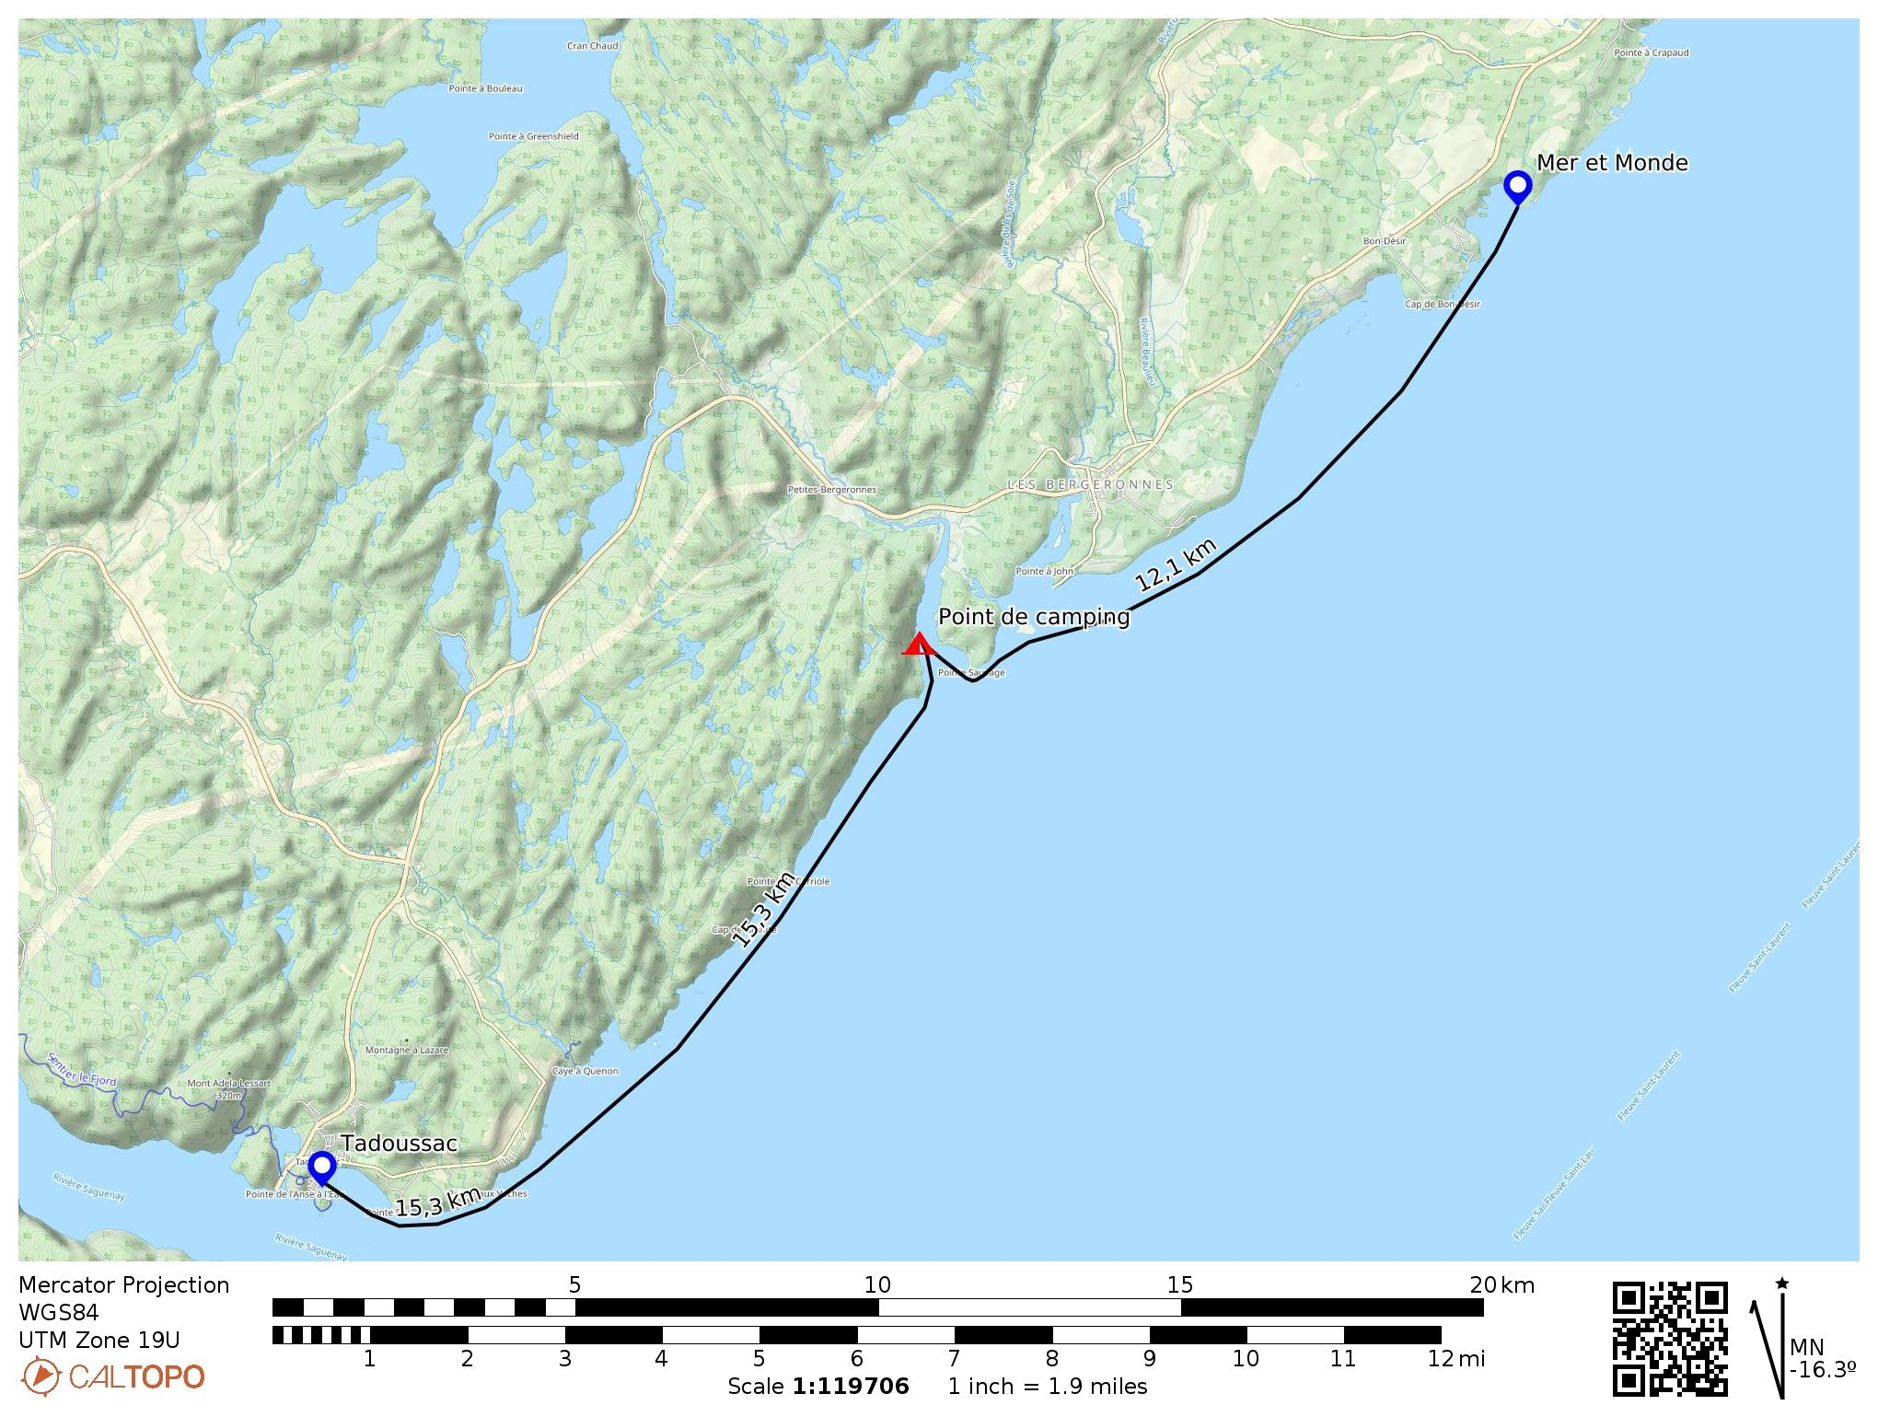
Itinerary

General course

The proposed expedition includes 2 days on the water. However, the duration of your stay will be 3 days. Depending on the weather and the date of your departure, the schedule and the activity may be changing. You will find a map of the expedition route in the appendix.

Arrival Day 1
You will arrive at Mer et monde écotours site the day before your departure date. As soon as you arrive, you will need to go to the reception office to check in. A campsite will be reserved for every participant, and the price is already included. At this moment, we’ll give you all the campground equipment and feel free to install yourself. A MANDATORY 1.5-hour meeting with the participants and the guides will take place at 6 h 00 p.m. on the same day. At this point, your guides will present the itinerary, distribute the included nautical equipment, and make sure everything is in place for the departure. They will on hand to answer any questions you may have, and to support you in your preparation if need be. Please note that this meal is not included in the package.

Day 2
Breakfast (included) on the first morning will be served between 6:30 and 7:00. Final preparations with your guides take place at 7:00 am. At this time, you will need to have your personal equipment ready to be put in the minibus. Once you have arrived on the beach at Tadoussac, you will prepare your kayak and get dressed after before the launch on the water. A lunch break will be provided two hours after the start of your expedition (lunch included). The afternoon will be spent covering the distance to our campsite at the Pointe Sauvage. In the evening, once you have set up your tent and made yourself comfortable, your guides will serve you a hearty meal (included).

Day 3
On the second morning, you will be managing your campsite and your equipment while your guides are preparing the breakfast (included). We will be ready to depart once the camp has been completely dismantled and all the equipment ready on the boats. A midday stop for lunch is planned (included). The rest of the day will be spent on the water to complete your adventure at Mer et monde écotours. Once there, you will need approximately 2 hours to sort out your personal equipment and everything that was lent. Afterwards, you will need to complete departure formalities. A final night's camping on the Mer et monde écotours site is included but is optional, at your discretion.

Meals
Mer et monde écotours is committed to offer a customized menu tailored to each expedition group. Our menus are sprinkled with local flavours, while respecting our sustainable vision of the environment. Fish, shellfish, wild meats, mushrooms and wild herbs, bannock, veggie pâté and homemade anergy ball will all be part of your meals. It is important to mention any allergies or special dietary requirements in advance, when you receive the questionnaire by e-mail, approximately one (1) month before your departure date. The menu will be presented to the participants 5 days before the expedition.

Summary
Arrival Day 1
- Arrival at Mer et monde écotours
- A MANDATORY 1.5-hour meeting with the whole group and the guides (6 p.m.).
- Meal not included.
- Overnight stay at Mer et monde écotours (included).

Day 2
- Breakfast (included)
- Meeting at 7 h 00 a.m. and preparation for the departure
- Launch from Tadoussac between 9 – 10 h00 a.m. and a 7 km trip.
- A lunch 1,5 hour in a unique site (included).
- Back on the water for an 8 km trip.
- Arrival at the wilderness campsite and set up the camp.
- Dinner with local flavours served by your guides (included).
- Legends at stories of the region.
Day 3
- Breakfast is served by your guides (included).
- Preparation for departure.
- Morning start and launching on the water for a 6 km trip.
- A dinner 1.5 hour on the Pointe à Théophile beach
- Back on the water for a 6 km trip.
- Arrival at Mer et monde écotours
- Repatriation of the equipment and cleaning.
- End of the activity
- A second overnight stay is available and included.

Travel logistics
Mer et monde écotours will take care of travel logistics between the departure and arrival points. You will be able to leave your car at Mer et monde écotours for the whole trip. Every participant will be transported in a 12-15-passenger minibus with their entire equipment. Besides, the trip logistic will be adapted depending on the itinerary of your expedition and your guides will tell you everything about it the day before your departure. Note that the minibus will always be at the disposition of the group in case of emergency during the trip.
Emergency plan and risk management
Mer et monde écotours takes part in the association Aventure Écotourisme Québec and its entire documentation is up to date. Mer et monde écotours must demonstrate that the prevention and emergency measures are adapted according to the standards of the environment. To prevent any related risk to the activity, every expedition giving by Mer et monde écotours have their own emergency and risk management plan. Our guides have their Restricted Operator’s Certificate-Maritime (ROC-M) and they are in constant communication with the Canadian Coast Guard. In addition, every kayak on the expedition is fitted with a geolocation system, delivered by SPOT. An onshore team is always on hand to aid if needed to be. We also have access to a fleet of motorboats to provide the necessary support.

Material and equipment supplied
Giving the specific nature of the equipment required for the activity, we will provide you with several items prior to departure.
- Tandem or solo kayaks (depending on skills). A minimum of one tandem is required for the whole trip.
- 1 - Paddle
- 1 - Spray Skirt
- 1 - Life Jacket (PFD)
- 1 - Wetsuit
- 1 - Paddling Jacket
- 1 - Pair of Neoprene Boots
- Safety equipment required by Transport Canada (buoyant heaving line, whistle, scoop, flashlight)
- Dry Bags: 2X20L and 1X30L

This all-inclusive package also includes camping equipment.
- Crockery set with utensils, plate and cup.
- MSR tent, -5 degree sleeping bag, self-inflating mattress and compressible pillow.
- Headlamp and individual quick-drying towel.
In case you have your own equipment, we welcome you to mention it to our team so we will be able to verify it beforehand. According to the legal approval, it is possible you will not be in the position of using your own material depending on whether it respects the standards.

Required equipment and material
Equipment (expedition only) | Nb. | Verified
Clothing
Base layer (top and bottom) | 1
Night Shoes | 1
Wool sock | 2
Underwear | 2
Warm sweater | 1
Pants | 1
Raincoat | 1
Wind proof pants (recommended) | 1
Toque | 1
Hat/Cap/Buff | 1
Equipment
Sunglasses | 1
Water bottle (1 L minimum) | 2
Lighter | 1
Headlamp | 1
Pharmacy
Toothbrush | 1
Toothpaste | 1
Dental floss | 1
Sun screen | 1
Lip balm | 1
Mosquito repellent | 1
Deodorant | 1
Contact lens case | -
Medication | -
Feminine hygiene equipment | -
Toilet paper (in a Ziploc bag) | 1
Various
Snacks | 4
Ziploc freezer bag | 4
Face mask | 3
Ginger pill (for seasickness) | -
Any other relevant material | -

Q and A

What services are offered at Camping Mer et monde écotours?

You'll find a full sanitary block with showers ($) and toilets. Near your camping area, 2 dry toilets are also available.

How does it work for expedition toilets??

There are several stops along the way, and we apply the Leave No Trace principles. At the Pointe Sauvage campground, a comfortable natural setting has been set up to respect your privacy.

What's the cancellation policy?
Please refer to this link.

Informations before arrival

E-mail information
The expedition is a much more personalize experience than the daily excursion. You will spend several days with your guides, and they would like to know a maximum of information about you. Approximately one (1) month before your departure date, we will send you an e-mail containing a questionnaire (summary of your food preferences, dislikes or any other particularities in your diet, vegetarian, vegan, gluten-free or other). In the same optic, your guides would appreciate knowing a bit more information about yourself. You’re welcome to send us a brief description of you as a person, what motivates you to take part in this adventure and any relevant experiences.

Acknowledgement and Assumption of Risks
After you have registered, you will receive an acknowledgement and assumption of risk document to fill. It is mandatory to entirely it and send it to us 10 days before the expedition. This document is not a waiver. Its sole purpose is to inform you of the activity inherent risks, the company’s specific policies and to provide us with information about your health and safety, such as allergies, fears, injuries, specific medical conditions. We thank you for taking the time to fill in the form completely and for being transparent about your mental and physical condition.

Questions and Additional Information
Expeditions are activities with multiple particularities. Feel free to contact our team by phone or by e-mail if you have any questions.
By phone: 418 232-6779 By e-mail: meretmonde@essipit.com

